**University of Nebraska Omaha**

**ISQA 4900 - Full Stack Application Development**

**Activity 3** - **Display, Search and Filter Data with Vue**

**Objectives**

* Demonstrate your ability to create a Vue.js program that displays, searches and filters data.
* You will need to demonstrate your knowledge of:
  + Initializing variables and assigning data
  + Syntax for Print and Input functions
  + Boolean expressions
  + Vue Directives: v-for, v-html, v-if, v-else, filtering data with Vue
  + Building a form and showing and hiding content.
  + Ability to debug errors found in a simple JavaScript program.

**Directions**

1. You will create a simple application similar to what we discussed in the lecture on Display, Looping, Searching Data in Vue.js. The Data for this project is in the form of a JSON file of Alumni of a university. Most of the fields are the typical name and address field and the last field in a binary field showing if the alminus had donated to the university in the last 12 months. Below is a sample of 4 records. And a link to the actual file which contains 25 records.

| [  {  "student_id": 101,  "first_name": "James",  "last_name": "Butler",  "address": "6649 N Blue Gum St",  "city": "New Orleans",  "state": "LA",  "zip": 70116,  "donor": false  },  {  "student_id": 102,  "first_name": "Josephine",  "last_name": "Darakjy",  "address": "4 B Blue Ridge Blvd",  "city": "Brighton",  "state": "MI",  "zip": 48116,  "donor": true  },  {  "student_id": 103,  "first_name": "Art",  "last_name": "Venere",  "address": "8 W Cerritos Ave #54",  "city": "Bridgeport",  "state": "NJ",  "zip": 8014,  "donor": true  },  {  "student_id": 104,  "first_name": "Lenna",  "last_name": "Paprocki",  "address": "639 Main St",  "city": "Anchorage",  "state": "AK",  "zip": 99501,  "donor": true  }  ] |
| --- |

Link to the JSON file you will use in your Vue applications:

<https://drive.google.com/file/d/1nh67HJ6sJTnz7TLJgqMJbO3Xa5fel9K9/view?usp=sharing>

1. You will construct an application which allows users to search for data by each column in the JSON array. Similar to the presentation you will add the JSON to an application and filter the data to quickly find data based on all fields in the array. Here are sample screenshots:

**No filter applied. Shows only first 5 of 25 records in full JSON file:**

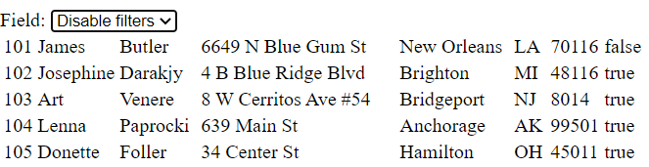

**First Name Filter Applied - search for all first names with “j” in first name.**

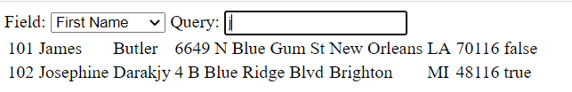

You should create the application to search and filter on First Name, Last Name Address, City and State for full credit.

**Resources**

The video and slides called “Displaying, Looping, Searching and Filtering Data in Vue” is the tutorial for this problem.

**Submitting your assignment**

1. When you are happy with your working web page including the embedded JavaScript, create a word document with the title 4900 Activity 3 and take screenshots similar to the ones shown above. Be sure to show a successful search of each of the 5 fields.

2. Upload the word document to Canvas. Also Zip Up the HTML page with JavaScript and upload to Canvas.

**Rubric**

|  | Exemplary  (from 90 to 100%) | Competent  (from 80 to 89%) | Acceptable  (from 70 to 79%) | Insufficient  (below 70%) |
| --- | --- | --- | --- | --- |
| JavaScript Code (max 15 pts) | Functions as described above and has appropriate comments in the code | Generally functions as described above and has some but not all comments | Partially functions as described above and may lack appropriate comments | Does not function as described above and lacks comments |

**Extra Credit Opportunity**

1. For up to 10 points extra credit add the ability to search for donors versus non donors with radio buttons similar to the original example.

2. Be sure to add screen shots of the extra credit features and note what you did for extra credit in the word document.